Ringtail Tally - Summary report Autumn 2022
Introduction
The autumn Western Ringtail Tally is the ninth tally, adding to a reliable set of observation data that will improve our knowledge about where Western Ringtail Possums are found and in what numbers. The main area of focus is the Geographe Catchment, where the greatest numbers of Western Ringtails are found, however, an increasing number of surveys have been carried out in the Dawesville, Mandurah, Lake Clifton area, at the northern end of the species range.
The Western Ringtail Possum is endemic to the southwest of WA and is listed as Critically Endangered under both the State Biodiversity Conservation Act (2016) and the Federal Environment Protection and Biodiversity Conservation Act (1999). It is, however, able to survive in peri-urban areas, as long as there are sufficient food tree species and water, and they are able to move about their territories without having to spend too much time on the ground. During the day, they shelter in tree hollows, rooves or a number of dreys (stick nests), spread across their territories.
This project idea was developed by the Geographe Catchment Council who have received funding from the National Landcare Program to deliver an annual “count event” in from 2016 to 2021. The Wirambi Landcare group have co-ordinated the Tally in the Dawesville - Mandurah area since Spring 2019.
Objectives of the Ringtail Tally
- To establish a set of suburban monitoring sites where western ringtail possums are counted annually using robust, repeatable methods.
- To capture data that will build knowledge about Ringtails, that can be used as a reference for population trends, future planning decisions and conservation projects.
- To provide preliminary data on the distribution and abundance of Ringtails in the Geographe Catchment and Mandurah area. Ideally the data set will help with planning decisions that affect Ringtail populations and habitat.
- To raise awareness in the community about Ringtails, which are endangered.
- To engage the community in citizen science to assist with endangered species conservation.

Table 1: Summary of Ringtail Tally data across all years (2016 to 2022)
Total number of evening surveys | 2,320
Total number of hours spent surveying | 1,059
Total number of ringtail sightings | 5,650
Total number of volunteers involved | 253
Total number of sites surveyed | 287
Avg number of surveys per site | 8.0
Avg number of ringtails per survey | 2.5
(note that surveys run for less than 10 minutes, or longer than 1.5hrs were excluded)
Methods
To participate in the Tally, observers were asked to choose a site, often a suburban block, less than 50m x 50m in area, and to survey that site for western ringtail possums, within a four week period, between April and May each year. The surveys give us an indication of how many individual ringtail possums are in each of the survey sites and how this changes over time. For a map of survey sites, see Appendix 1.

The Ringtail Tally event is advertised to the community via local newspaper advertisements in the Busselton-Dunsborough area, GeoCatch Facebook, website and network email distribution list. Similarly, the survey is supported and advertised by the Leschenault Catchment Council (LCC), and also promoted in 'Bushland News', the newsletter of the Department of Biodiversity, Conservation and Attractions (DBCA).
Participants were provided with a survey data sheet to record sightings (see Appendix 2). The data sheet, developed with assistance from DBCA, included the following:
- Count method – participants were requested to count the number of ringtails visiting their house block between half an hour before sunset and 10.00 pm, on any given day.
- Number of counts. People could do as many counts as they wish over the 30 day, four week period (max 30 counts) but we suggested a minimum of 2 counts per week, over the four-week survey period (minimum of 8 counts).
- Survey effort – Participants were not required to be on the lookout for ringtails the whole evening but were asked to record the length of time spent keeping an eye out for ringtails.
- Positive identification – Observers were issued with photos of ringtail possums to help distinguish them from the common Brushtail Possum. They were asked to estimate how confident they were that they recorded ringtail possums (1 = uncertain, 5 = 100% certain). People were requested to send a photo of the ringtail where possible.
- Number of individuals counted - The maximum number of ringtails estimated to visit on any given night is based on the maximum number seen together at any one time. If two physically distinct animals visit at different times, they were counted as two separate animals.
- Submitting data - Participants provided data by hardcopy/post or electronically, via email.

Results
Table 2: A summary of the data captured through the eight surveys is presented below. Key data were selected and presented as a “snapshot” (see appendix 3 – 2019 example) using infographics and published in the local newspaper to generate awareness of ringtails and the results of the event.
Summary information | 2016 Autumn  Tally | 2017 Autumn  Tally | 2017 Spring  Tally | 2018 Autumn  Tally | 2019 Autumn  Tally | 2019  Spring  Tally | 2020  Autumn  Tally | 2021  Autumn  Tally | 2022  Autumn  Tally
Main survey period  (March to May) | 1 April to  30 May 2016 | 16 March to  30 April 2017 | 21 Sept. to  10 Nov. 2017 | 16 March to  20 May 2018 | 1 April to  20 May 2019 | 15 Sept to  30 Nov 2019 | 10 April to  17 May 2020 | 4 April to 27 May 2021 | 6 April to 21 May 2022
Number of Active Observers | 40 | 37 | 18 | 34 | 35 | 16 | 57 | 37 | 81
Number of sites surveyed | 47 | 37 | 18 | 39 | 50 | 25 | 77 | 35 | 101
Total number of ringtail possum sightings during evening surveys (Activity measure, sum Max Count, includes double counting)* | 520  (n=227 surveys) | 684  (n=268 surveys) | 206  (n=83 surveys) | 698  (n=258  surveys) | 693  (n=250 surveys) | 188  (n= 90 surveys) | 1080  (n=417 surveys) | 670  (n=241 surveys) | 939  (n=454 surveys)
Number of sites with ringtail possums recorded as present. | 37 (79%) | 26 (70%) | 13 (72%) | 30 (77%) | 43 (86%) | 21 (84%) | 63 (81%) | 28 (80%) | 72 (72%)
Average number of ringtail possums  sighted per evening survey | 2.3  (n=227 surveys) | 2.6  (n=268 surveys) | 2.5  (n=83 surveys) | 2.7  (n=258 surveys) | 2.8  (n=250 surveys) | 2.1  (n= 90 surveys) | 2.6  (n=417 surveys) | 2.7  (n=241 surveys) | 2.1  (n=454 surveys)

Summary information | 2016 Autumn  Tally | 2017 Autumn  Tally | 2017 Spring  Tally | 2018 Autumn  Tally | 2019 Autumn  Tally | 2019  Spring  Tally | 2020  Autumn  Tally | 2021  Autumn  Tally | 2022  Autumn  Tally
Number of sites where ringtail possums were observed with young (combined across surveys) | 17/49 sites (35%) | 16/29 sites (55%) | 7/14 sites (50%) | 26/40 sites (65%) | 18/25 sites (72%) | 17/27 sites (63%) | 33/53 sites (62%) | 22/35 sites (63%) | 13/30 sites (43%)
Number of ringtails seen per hour of survey (averaged across sites and data sheets*) | 5.4  (n=227 surveys) | 6.5  (n=268 surveys) | 6.7  (n=83 surveys) | 6.3  (n=258 surveys) | 7.3  (n=250 surveys) | 5.7  (n=90 surveys) | 6.9  (n=417 surveys) | 6.6  (n=242  surveys) | 6.7  (n=241  surveys)
Survey Effort:

Total number of evening surveys* | 227 | 268 | 83 | 258 | 250 | 90 | 417 | 255 | 462
Average number of evening surveys per site | 4.8 | 7.2 | 4.6 | 6.6 | 5.0 | 3.5 | 5.4 | 7.2 | 4.6
Average time spent surveying each evening* | 26 min | 28 min | 26 min | 32 min | 28 min | 23 min | 28 min | 30 min | 25 min
Total number of hours spent surveying  (across all sites)* | 100 hours | 123 hours | 36 hours | 139 hours | 119 hours | 39 hours | 192 hours | 120 hours | 192 hours
Summary information | 2016 Autumn  Tally | 2017 Autumn  Tally | 2017 Spring  Tally | 2018 Autumn  Tally | 2019 Autumn  Tally | 2019  Spring  Tally | 2020  Autumn  Tally | 2021  Autumn  Tally | 2022  Autumn  Tally
% of feeding observations on Coastal Peppermint trees | 55%  (total of 55 reports of feeding) | 44%  (total of 48 reports of feeding) | 46%  (total of 28 reports of feeding) | 50%  (total of 38 reports of feeding) | 51%  (total of 37 reports of feeding) | 14%  (total of 42 reports of feeding) | 51%  (total of 37 reports of feeding) | 30%  (total of 77 reports of feeding) | 23%  (total of 104 reports of feeding)
Number of sites where food is provided for ringtail possums (mostly fruit). | 8 (17%)  (n=48 reports) | 11 (31%)  (n=36 reports) | 2 (12%)  (n=17 reports) | 8 (30%)  (n=27 reports) | 9 (21%)  (n=44 reports) | 3 (12%)  (n=25 reports) | 23 (29%)  (n=79 reports) | 9 (25%)  (n=36 reports) | 7 (18%)  (n=39 reports)
Site description:
Suburban Garden | 30 (48%) | 33 (61%) | 14 (56%) | 28 (51%) | 21 (44%) | 49 (56%) | 37 (62%) | 17 (49%) | 40 (35%)
Park/sports field | 13 (21%) | 9 (17%) | 1 (4%) | 9 (16%) | 4 (8%) | 0 (0%) | 2 (3%) | 1 (3%) | 4 (3%)
Semi-rural House Block | 11 (18%) | 9 (17%) | 5 (20%) | 11 (20%) | 7 (15%) | 31 (36%) | 16 (27%) | 8 (23%) | 14 (12%)
Native Bushland | 8 (13%) | 3 (6%) | 5 (20%) | 7 (13%) | 16 (33%) | 7 (8%) | 5 (8%) | 9 (26%) | 56 (49%)

*Surveys run for less than 10 minutes, or longer than 1.5hrs were excluded.

Figure 1: Number of sites surveyed and number of observers in autumn

Figure 2: Average number of Ringtails per hour (±SE) during autumn. Surveys less than 10 minutes and greater than 1.5 hrs were excluded. The number of surveys given in brackets below.

Ringtail Mortality
Table 3: Identified causes of mortality have been summed across all surveys (2016 to 2022), n = 508 reported deaths, across all (n = 127 sites)
Cause of death | 2016 to 2022  (n=508 reports)
Roadkill | 63% (318)
Dog | 6% (32)
Cat | 4% (21)
Fox* | 1% (6)
Raven | 1%(4)
Electrocutions | 1% (3)
Fire injury | <1% (2)
Other/Unknown | 9% (45)
*Note that fox predation is largely undetected, so would be higher than indicated here.

Bushland vs suburban gardens
Across all surveys since 2016, the average number of ringtails recorded per hour was slightly greater in suburban gardens (6.2 ringtails/hr, SE ± 0.2, n=1,230 surveys) compared with native bushland sites (4.8 ringtails/hr, SE ± 0.2, n=367 surveys).
Autumn vs Spring surveys
Across all surveys since 2016, the average number of ringtails recorded per hour was similar in Spring surveys (6.3 ringtails/hr, SE ± 2.7, n=173 surveys), compared with Autumn surveys (6.6 ringtails/hr, SE ± 2.7, n=2,143 surveys).
Identification of ringtails
Photos were submitted from six sites, five were ringtails (one uncertain). In almost all cases, observers were confident in their identification of Western Ringtail Possums, as determined by phone interviews, for 79 out of 81 observers (98%).

Regional variation
Table 4: Average number of ringtails seen in different Regions (2016 to 2022)
Region | Number of evening surveys | Average number of Ringtails seen per hour
Dawesville/Peel-Harvey | 201 | 8.7 (SE ± 2.9)
Geographe Bay | 1,329 | 7.0 (SE ± 2.8)
Margaret River | 82 | 5.3 (SE ± 2.4)
Leschenault | 253 | 4.4 (SE ± 2.3)

Table 5: Average number of ringtails per hour in the different suburbs
(2016 to 2022, blue shading identifies suburbs with fewer than three observers/sites – so results not necessarily representative of the suburb)

Location  (Local Area) | Number of Observers | Number of evening surveys | Average number of Ringtails seen per hour
Bouvard | 8 | 110 | 12.5
Quindalup | 7 | 67 | 7.6
Dunsborough | 33 | 262 | 6.5
Busselton | 46 | 565 | 6.1
Cowaramup | 3 | 42 | 5.6
Vasse | 4 | 126 | 5.1
Geographe | 9 | 101 | 5.1
Herron | 3 | 27 | 5.0
Dawesville | 9 | 104 | 4.7
Broadwater | 17 | 106 | 4.7
Capel | 5 | 28 | 4.3
Bunbury | 18 | 210 | 4.1
West Busseton | 3 | 20 | 3.4
South Bunbury | 6 | 32 | 3.2
Margaret River | 18 | 125 | 2.9
Yallingup | 6 | 54 | 1.8
Leschenault | 4 | 20 | 1.8
Australind | 6 | 30 | 1.8
Stratham | 2 | 17 | 17.2
Wonnerup | 2 | 57 | 12.4
Witchcliffe | 1 | 10 | 4.5
Bovell | 1 | 8 | 4.0
Dalyellup | 1 | 8 | 4.0
Carbunup River | 2 | 16 | 3.4
Wannanup | 1 | 4 | 1.7
Ferguson | 1 | 14 | 1.2
Pelican Pt | 1 | 6 | 0.0
Nillup | 1 | 7 | 0.0
Abba River | 1 | 8 | 0.0

Figure 3: Average no. of Ringtails per hour (±SE) during autumn in Geographe Bay
(The number of surveys given in brackets)*

Figure 4: Average number of Ringtails per hour (±SE) during autumn in Dawesville/Peel-Harvey.
(The number of surveys given in brackets)*

Figure 5: Average number of Ringtails per hour (±SE) during autumn in Leschenault.
(The number of surveys given in brackets)*

Figure 6: Average number of Ringtails per hour (±SE) during autumn in Margaret River.
(The number of surveys given in brackets)*

*Surveys less than 10 minutes and greater than 1.5 hrs were excluded.
Conclusion
The number of Tally participants was greater than in previous years, with 81 observers taking part in the 2022 Autumn survey, who carried out 454 surveys across 101 sites (see Table 2 and Figure 1). A total of 939 possum sightings were recorded, reflecting the reduced survey participation.
The overall count of possums per hour was comparable with previous years, suggesting that the number of ringtail possums in the urban areas surveyed is stable (Figure 2).
At the request of the Ringtail Tally participants/organisers, I have included some graphs of regional/local trends in the reported number of ringtails seen per hour, so that they can begin to look at regional trends (Figures 3 to 6). Broadly speaking, the regional trends are similar to the overall trend (Figure 2).
Across all surveys, roads are still the dominant cause of ringtail mortality (Table 3) but note that fox and cat predation would go largely un-detected. Unlike previous years, only 23% of feeding records were of ringtails in peppermint trees (23% of 104 feeding records, Table 2). Also, unlike in previous years, half of the ringtail possum records were in native bushland, with only 35% being in suburban gardens (Table 2).
The number of ringtails recorded per hour, was highest in the Peel-Harvey / Bouvard / Dawesville area, followed by Geographe Bay, and lowest in Margaret River sites (Tables 4 and 5, see also map of survey locations in Appendix 1). Note however, the smaller sample sizes in all but the Geographe Bay areas mean that such results could be driven by sampling and observer bias and should be treated cautiously.
The opportunity to hold future Ringtail Tally events looks promising with many other groups from different catchments expressing interest in taking part to supporting the event. Parks and Wildlife have also indicated their support to run the Tally again in 2023. Funding will need to be sought for promotional, coordination and reporting activities where other catchments or additional sites are to be included.
The Ringtail Tally has provided a new way to engage the community in citizen science and promote awareness of our endangered Western Ringtail Possums. Repetition of the survey in future years would provide a better understanding of where Western ringtail Possums occur and inform planning decisions that affect the survival of this endangered species.
Report compiled by Nicole Lincoln (Geocatch; nicole.lincoln@dwer.wa.gov.au) and Geoff Barrett (Parks and Wildlife; geoff.barrett@dbca.wa.gov.au) on behalf of the Western Ringtail Action Group.
This project was funded by the 25th Anniversary National Landcare Program

Appendix 1 – Map of Ringtail Tally survey locations, size of green circle indicates average number of possums recorded
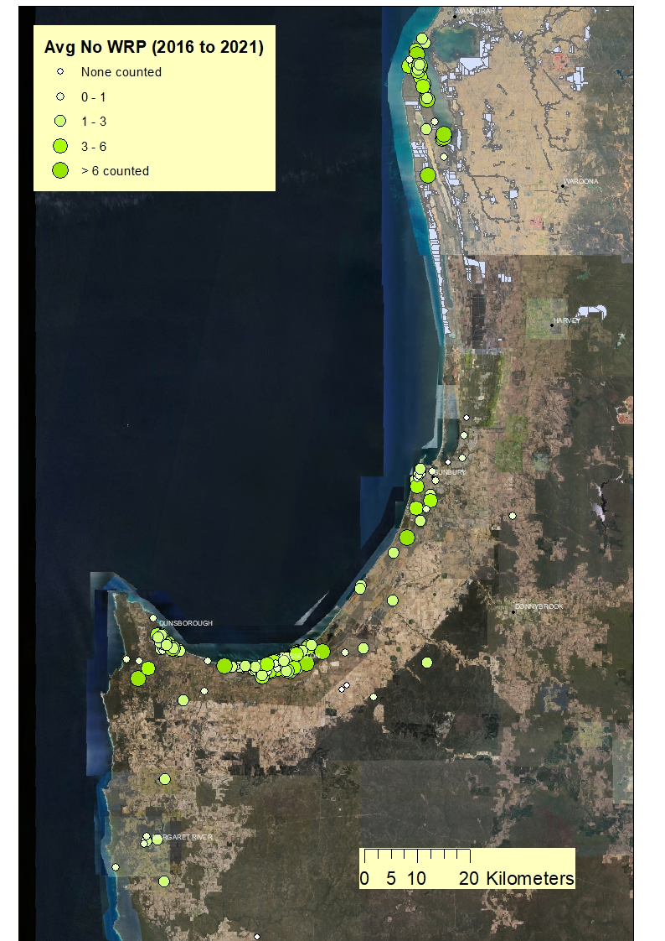

Appendix 2 - Snapshot of results – example data sheet
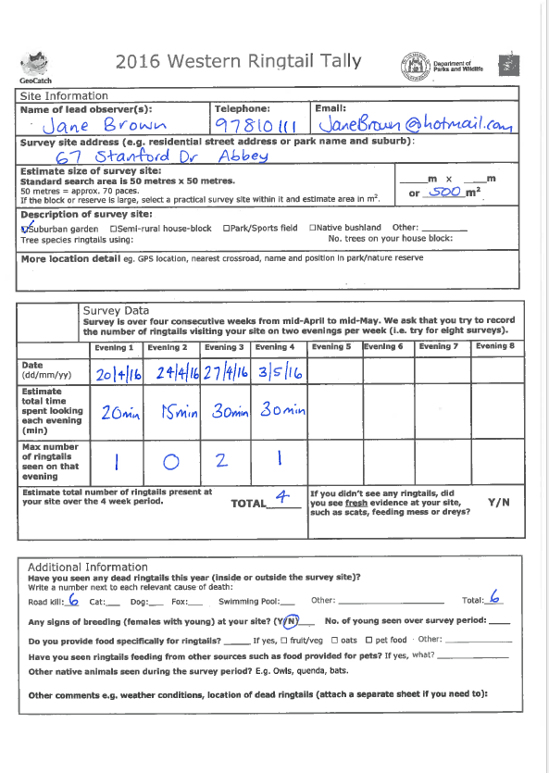
Appendix 3 - Snapshot of the 2019 results
